**TITLE: NAVIGATION IN USER INTERFACE DESIGN IN EQUIPMENT STORE MANAGEMENT INFORMATION SYSTEM**

**CASE OF COMPUTECH LIMITED**

**NAME: MURIGI DANIEL CHEGE**

**NO: BIT-001-7391/2013**

A Research project submitted to department of Information Technology in School of Computing and Information Technology for the requirement of Bachelor in Information Technology of Jomo Kenyatta University of Agriculture and Technology.

November 2016

**Declaration**

I hereby declare that this is my original work of software research project proposal and has not been in any other institution.

……………………………………...

Student’s Name

……………………………………… ……………………….

Signature Date

I hereby declare that this software research proposal has been submitted with approval as the university supervisor.

Mr. Charles Mwambu

Lecturer’s name

………………………………. ………………………………

Signature Date

**Acknowledgement**

Success in life is never attained single handedly. It is on this note that I express my heartfelt Gratitude to God for the strength and wisdom; and to various people who have assisted me in various ways to accomplish this project. My sincere appreciation goes to my project supervisor Mr. Charles Mwambu for his useful and constructive guidance on this project, also to the JKUAT IT Department and the various lecturers who took me through the course without whom the project would have been impossible to implement and thus it will be my pressure to thank my classmates and guardian who have supported and encouraged me throughout the writing of this project, for they have provided valuable assistance and guidance.

**Abstract**

This documentation explores the way of reducing challenges encountered during the process of repairing and troubleshooting the various Equipment.

It will address how the various Equipment are recorded, picked and returned into the store, sharing of information between the various parties by using a modern computerized system to enhance the current manual system also the constraints which may dock the progress of the project and its execution. The system will also use the existing data to analyze the work done by each Engineer for a certain period.

It also presents a breakdown of necessary resources, time plan and the finances of hardware and software needed for the running of the system.

Table of Contents

Table of Contents 5

CHAPTER ONE 1

1.1 Background Information 1

1.2 Introduction of Research Area 2

1.3 Problem Statement 2

1.4 Proposed Solution 4

1.5 Project Objective: 5

1.5.1 General Objective 5

1.5.2 Specific Objectives 5

1.6 Research Question 5

1.7 Justification 5

1.8 Proposed Research and System Methodologies 6

1.9 Scope 10

CHAPTER TWO 11

2.1 Introduction Literature Review 11

2.2 Theoretical review/Conceptual Framework 11

2.1.1 Principles/patterns used in implementing of user interface design 12

2.1.2 Challenges encountered while employing navigability in user interface design 14

2.1.3 Techniques used to evaluate navigability in user interface design 15

2.1.4 How to gauge navigation in user interface 15

2.1.5 Patterns in Navigation Design 16

2.3 Critique of Literature Review 18

2.4 Research gaps 18

2.5 Conclusion 18

CHAPTER THREE 19

3.1 Introduction 19

3.2 Systems Development Methodology 19

3.3 Feasibility study 19

3.3.1 Economical feasibility 19

3.3.2 Economic feasibility report 19

3.3.3 Operational feasibility 20

3.3.4 Operational feasibility report 20

3.3.4 Technical feasibility 20

3.3.5 Legal feasibility 21

3.3.6 Legal feasibility report 21

3.4 Requirements elicitation 21

3.5 Data and System Analysis 22

3.5.1 Analysis of the findings 22

3.5.2 Report of Questionnaires 23

3.5.4 Report of observation 25

3.5.5 Conclusion 25

3.10.1 Functional Requirements 26

3.10.2 Non-functional Requirements 28

3.8 Physical and logical design 29

3.8.1 Process Flowchart 29

3.8.2 Use case Diagram 30

3.8.3 Login flowchart 31

3.8.4 Administrators’ Activity diagram 32

3.8.5 Store Managers’ Activity diagram 33

3.8.6 Engineers’ Activity diagram 34

3.8.7 Engineers flowchart 35

3.8.8 Administrators’ Sequence diagram 36

3.8.9 Engineers’ Sequence Diagram 37

3.8.10 Class Diagram 38

3.8.11 Interface Design 39

3.8.12 Login Interface/home Page 39

3.8.13 Admin Interface 39

3.8.14 Store Managers’ Interface 40

3.9 System Architecture 41

3.9.1 Deployment Diagram 41

3.9.2 System Framework 41

3.10 Database 43

3.10.1 Database design 43

3.11 Database Normalization 45

3.12 Entity Relationship Diagram 47

CHAPTER FOUR 47

4.1 Introduction 48

4.2 System code generation 48

4.3 Testing 52

4.3.1 Test plan 52

4.3.2 Test Results 53

4.4 Conclusion 58

4.5 Limitations 58

4.6 Recommendations 58

References 59

Appendices 59

1.11.0 Resources, Timeplan and Budge 59

1.11.1 Hardware Requirements 59

1.11.2 Software Requirements 60

1.11.3 Human Resources 60

Appendix i. Budget 60

Appendix ii. Gantt chart 62

Appendix iii. Work Plan 63

Appendix iv: Questionnaires 64

Appendix v: User Manual 74

CHAPTER ONEPAGEREF _Toc467413679 \h1

1.1 Background InformationPAGEREF _Toc467413680 \h1

1.2 Introduction of Research AreaPAGEREF _Toc467413681 \h2

1.3 Problem StatementPAGEREF _Toc467413682 \h2

1.4 Proposed SolutionPAGEREF _Toc467413683 \h4

1.5 Project Objective:PAGEREF _Toc467413684 \h4

1.5.1 General ObjectivePAGEREF _Toc467413685 \h4

1.5.2 Specific ObjectivesPAGEREF _Toc467413686 \h5

1.6 Research QuestionPAGEREF _Toc467413687 \h5

1.7 JustificationPAGEREF _Toc467413688 \h5

1.8 Proposed Research and System MethodologiesPAGEREF _Toc467413689 \h5

1.9 ScopePAGEREF _Toc467413690 \h9

CHAPTER TWOPAGEREF _Toc467413691 \h10

2.1 Introduction Literature ReviewPAGEREF _Toc467413692 \h10

2.2 Theoretical review/Conceptual FrameworkPAGEREF _Toc467413693 \h11

2.1.1 Principles/patterns used in implementing of user interface designPAGEREF _Toc467413694 \h12

2.1.2 Challenges encountered while employing navigability in user interface designPAGEREF _Toc467413695 \h14

2.1.3 Techniques used to evaluate navigability in user interface designPAGEREF _Toc467413696 \h14

2.1.4 How to gauge navigation in user interfacePAGEREF _Toc467413697 \h15

2.1.5 Patterns in Navigation DesignPAGEREF _Toc467413698 \h15

2.3 Critique of Literature ReviewPAGEREF _Toc467413699 \h17

2.4 Research gapsPAGEREF _Toc467413700 \h18

2.5 ConclusionPAGEREF _Toc467413701 \h18

CHAPTER THREEPAGEREF _Toc467413702 \h18

3.1 IntroductionPAGEREF _Toc467413703 \h18

3.2 Systems Development MethodologyPAGEREF _Toc467413704 \h18

3.3 Feasibility studyPAGEREF _Toc467413705 \h19

3.3.1 Economical feasibilityPAGEREF _Toc467413706 \h19

3.3.2 Economic feasibility reportPAGEREF _Toc467413707 \h19

3.3.3 Operational feasibilityPAGEREF _Toc467413708 \h19

3.3.4 Operational feasibility reportPAGEREF _Toc467413709 \h19

3.3.4 Technical feasibilityPAGEREF _Toc467413710 \h20

3.3.5 Legal feasibilityPAGEREF _Toc467413711 \h20

3.3.6 Legal feasibility reportPAGEREF _Toc467413712 \h21

3.4 Requirements elicitationPAGEREF _Toc467413713 \h21

3.5 Data and System AnalysisPAGEREF _Toc467413714 \h22

3.5.1 Analysis of the findingsPAGEREF _Toc467413715 \h22

3.5.2 Report of QuestionnairesPAGEREF _Toc467413716 \h22

3.5.4 Report of observationPAGEREF _Toc467413717 \h24

3.5.5 ConclusionPAGEREF _Toc467413718 \h25

3.10.1 Functional RequirementsPAGEREF _Toc467413719 \h26

3.10.2 Non-functional RequirementsPAGEREF _Toc467413720 \h27

3.8 Physical and logical designPAGEREF _Toc467413721 \h28

3.8.1 Process FlowchartPAGEREF _Toc467413722 \h28

3.8.2 Use case DiagramPAGEREF _Toc467413723 \h29

3.8.3 Login flowchartPAGEREF _Toc467413724 \h30

3.8.4 Administrators’ Activity diagramPAGEREF _Toc467413725 \h31

3.8.5 Store Managers’ Activity diagramPAGEREF _Toc467413726 \h32

3.8.6 Engineers’ Activity diagramPAGEREF _Toc467413727 \h33

3.8.7 Engineers flowchartPAGEREF _Toc467413728 \h34

3.8.8 Administrators’ Sequence diagramPAGEREF _Toc467413729 \h35

3.8.9 Engineers’ Sequence DiagramPAGEREF _Toc467413730 \h36

3.8.10 Class DiagramPAGEREF _Toc467413731 \h37

3.8.11 Interface DesignPAGEREF _Toc467413732 \h38

3.8.12 Login Interface/home PagePAGEREF _Toc467413733 \h38

3.8.13 Admin InterfacePAGEREF _Toc467413734 \h39

3.8.14 Store Managers’ InterfacePAGEREF _Toc467413735 \h39

3.9 System ArchitecturePAGEREF _Toc467413736 \h40

3.9.1 Deployment DiagramPAGEREF _Toc467413737 \h40

3.9.2 System FrameworkPAGEREF _Toc467413738 \h41

3.10 DatabasePAGEREF _Toc467413739 \hError: Reference source not found

3.10.1 Database designPAGEREF _Toc467413740 \h42

3.11 Database NormalizationPAGEREF _Toc467413741 \h45

3.12 Entity Relationship DiagramPAGEREF _Toc467413742 \h47

CHAPTER FOURPAGEREF _Toc467413743 \h47

4.1 IntroductionPAGEREF _Toc467413744 \h47

4.2 System code generationPAGEREF _Toc467413745 \h47

4.3 TestingPAGEREF _Toc467413746 \h52

4.3.1 Test planPAGEREF _Toc467413747 \h52

4.3.2 Test ResultsPAGEREF _Toc467413748 \h52

4.4 ConclusionPAGEREF _Toc467413749 \h57

4.5 LimitationsPAGEREF _Toc467413750 \h57

4.6 RecommendationsPAGEREF _Toc467413751 \h58

ReferencesPAGEREF _Toc467413752 \h58

AppendicesPAGEREF _Toc467413753 \h59

1.11.0 Resources, Timeplan and BudgePAGEREF _Toc467413754 \h59

1.11.1 Hardware RequirementsPAGEREF _Toc467413755 \h59

1.11.2 Software RequirementsPAGEREF _Toc467413756 \h59

1.11.3 Human ResourcesPAGEREF _Toc467413757 \h59

Appendix i. BudgetPAGEREF _Toc467413758 \h59

Appendix ii. Gantt chartPAGEREF _Toc467413759 \h60

Appendix iii. Work PlanPAGEREF _Toc467413760 \h61

Appendix iv: QuestionnairesPAGEREF _Toc467413761 \h62

Appendix v: User ManualPAGEREF _Toc467413762 \h76

**List of Tables**

Table 1 People involved in data collection 22

Table 2 users table 43

Table 3 Customers table 43

Table 4 Equipments table 44

Table 5 System mail 45

Table 6 Equipment history 45

Table 7 GUI testing 53

Table 8 Unit test 54

Table 9 Acceptance testing 55

Table 10 Module testing 56

Table 11 Integration testing 57

Table 12 Functional testing 57

Table 13 Budget 61

Table 14 Budget 61

Table 15 Work plan 63

**List of Figures**

Figure 1 Pie chart 23

Figure 2 bar graph 24

Figure 3 misplacement pie chart 24

Figure 4 Time bar graph 26

Figure 5 process flow 29

Figure 6 use case diagram 30

Figure 7 login process 31

Figure 8 Admin activity diagram 32

Figure 9 store manager activity diagram 33

Figure 10 Engineer activity diagram 34

Figure 11 picking and returning of equipment’s 35

Figure 12 Admin sequence diagram 36

Figure 13 Engineer sequence diagram 37

Figure 14 Class diagram 38

Figure 15 home page/login mockup 39

Figure 16 Admin interface 39

Figure 17 store manager mockup 40

Figure 18 Deployment diagram 41

Figure 19 Entity relationship diagram 47

Figure 20 Gantt chart 62

# CHAPTER ONE

**INTRODUCTION**

# 1.1 Background Information

Computech Limited is a pan-African business technology Solutions Company founded and headquartered in Kenya. Their business is founded on three core pillars of Trust, Experience and Commitment. Computech was established in 1987. Beyond Kenya, we also have offices in Uganda, Tanzania, Rwanda, South Sudan, Burundi & Zambia.

As a respected technology solutions partner, They specialize in providing professional services, infrastructure solutions, technical support and technology outsourcing to all market sectors and with a strong focus on the Banking & Financial Services Industry, Telecommunications, Government & Education, Corporate, Aviation and Manufacturing as well as Non-governmental organizations.

Computech Headquarters are located in Waiyaki Way, Opposite Lion Place, Westlands

There are several sections in the ICT department namely

* I.C.T. Service center
* Enterprise Division
* System Administration
* Networking
* Cisco Division
* Service center
* Project Management
* ICT Security and Architecture

Each of these sections has a team leader and they meet weekly to keep track of the pre-identified objectives and identify issues and come up with an action plan to solve the problem. Key Performance Indicators and Key Results Areas offer guideline on how the services are rendered. The task is the boss and the highest responsibility of an individual is to serve rather than to rule in these sections.

Whenever necessary, training is conducted amongst the team members to improve rendering of service and incorporate knowledge to the team members.

# 1.2 Introduction of Research Area

It’s an area concerned in exploring new ways to make the software which we work with easier to navigate, to learn and friendlier to use. The major focus is the focus on maximizing usability and the user experience. The goal of user interface design is to make the user's interaction as simple and efficient as possible, in terms of accomplishing user goals. To achieve this proper navigation design principles must be followed in order to gain an understanding of human perception.

This area encourages and motivates the users of the system due to the ease of using the system. With this consideration in mind, it enables the designers to keep in mind the considerations of the users and bring down the probability of the users rejecting the system.

With this knowledge, i will be able to create a system with some of this features to enable the various parties to transform the information from one state to the other and generate some reports for evident of work done for a particular period.

In combination with other database features, there is improved speed of information retrieval from the database. This data will also be of importance to other modules of the system such as the verification which will extract some details concerning the Equipment picked and send the details to the relevant parties.

This area will enable companies in proper management of data positioned on a central place or distributed scenario. Whenever queries are required to be made, they can be performed on this data to achieve various purposes.

# 1.3 Problem Statement

Since the start of Computech limited, the number of clients sourcing services such as servicing , repairing and troubleshooting of various equipment’s has rapidly raised over the years. Due to this the service center requires an automated system to capture the progress of the various equipment’s in and out of the store. The current system demands recording of newly brought in equipment in a book whose contents are always dormant and never used to help in another process. The same information is also duplicated in a similar book by the Engineers when picking Equipment for repair or troubleshooting and also while returning the same Equipment. The following are some of the challenges faced within the process.

**Time wastage and Inefficiency**: A lot of time is wasted by the engineers when recording the equipment they want to work on from the store and also when returning the same and also when trying to search for a previously recorded Equipment.

**Storage and retrieval of information:** The current system stores all of its information in file cabinets and this makes it time consuming to retrieve a record from the previously stored records which made it even more difficult for engineers to update record in the archives. A very high risk of data loss is eminent in case of any natural calamity as records are kept in one place and it’s not easy to make backups. It also becomes very difficult for the store managers to arrange the files to their respective cabinets.

**Equipment lose:** At frequent times there are cases whereby clients equipment cannot be retrieved from the store since there is no way of tracing back which Engineer was working on it and also at which shelf it was placed last.

**Insufficient workforce monitoring:** Currently there is no way of telling which Engineer worked on which equipment and at what time, thus there are cases of incomplete work/undone work for equipment’s that were brought in by the various clients. The Engineer’s also don’t have a way of presenting what they have been doing throughout the week.

**Poor equipment recording:** Ones the equipment’s are brought in, they are recorded on a different file from which the picked equipment’s are recorded and thus there in inconsistency in making reference to various items.

**Sluggish Labor:** One**s** the Engineers have been assigned various items to either repair or troubleshoot, some take a lot of time before completing the assignment and even abandon the item if the challenge becomes too much.

**Deprived Client communication:** At some point after the client equipment has been repaired, it takes some time before he/she is alerted on the status of his equipment and thus most clients will sometime present themselves physically to come and check on the progress of their equipment(s).

# 1.4 Proposed Solution

A proposal to develop a computerized database system that will solve the currently experienced problems Computech by:

INFORMATION SHARING: Passing of information between various parties in the department and mostly the Engineers who need to present what they have done in a particular period.

EFFICIENCY: Locating of records will be faster and simple no matter how deep or old the record is.

INFORMATION SECURITY: Since the information will be stored on a secure database, it will be difficult for unauthorized parties to access the information. The backups will also be used in case the system fails or if the information becomes corrupted.

DATA STORAGE: The paper work will be reduced by the computerized system as it will offer data storage which will be more secure. This will make it easy to capture the various stages reached by the items.

DATA INTEGRITY: The information will be more accurate since the database will provide security measures to only those who are allowed to access certain records from the database, thus the information will be free from manipulation.

TIME CONCIOUS: The retrieval of information will be faster by the use of the computerized system as the various parties will only be required to provide the ticket numbers of the items in order to retrieve it or its status from the database.

NAVIGABILITY: The system will embrace on ease of navigation to allow the various users to move from one page to the other smoothly and with minimal time possible.

# 1.5 Project Objective:

## 1.5.1 General Objective

To develop a computerized system that will address problems faced by Computech service center in terms of record keeping and retrieval, Communication, management, information sharing and monitoring of various Engineers activities in the service center.

## 1.5.2 Specific Objectives

1. To examine the principles of navigation in user interface design.
2. To inspect the approaches of navigation in user interface design.
3. To explore the challenges of navigation design in web based information systems.
4. To determine how to implement navigation in web based information systems.

# 1.6 Research Question

1. What are the principles used on implementation of navigation in web based information systems?
2. What are the approaches to web navigation design?
3. Which are the challenges of navigation in web based information systems?
4. Which methods are used in implementation of navigation in web based information systems?

# 1.7 Justification

The purpose of the research is to automate the process by which the various Equipment are recorded into the store and also improve on the manner in which Engineers pick the various Equipment from the store without having to fill in repetitive details each time they need to pick or return an Equipment.

This solution will solve the problems currently encountered by the department and also improve on information presentation in terms of engineers being able to present what they have been doing for a particular period of time. The system will also provide a history on how Equipment have been flowing to and from the store and also indicate on which shelves the Equipment are at.

The solution will also contribute to the company by making sure the Engineers work are is monitored and in any case rewarded since the system will be able to capture and generate reports on the number of items a certain Engineer has worked on in a particular time.

# 1.8 Proposed Research and System Methodologies

In order to achieve the objectives of the system the method i used was **DSDM (**Dynamic Systems Development Method) which is an agile project delivery framework, primarily used as a software development method. It is a framework which embodies much of the current knowledge about project management. DSDM is rooted in the software development community, but the convergence of software development, process engineering and hence business development projects has changed the DSDM framework to become a general framework for complex problem solving tasks. The DSDM framework can be implemented for agile and traditional development processes.

**The importance of this methodology includes:**

* Its straight forward framework based on best principles to start implementing a project structure.
* It’s simple to use.
* It’s extendible.
* It’s not calming to be the solution to all kind of projects.
* Results of development are directly and promptly visible.
* Since the users are actively involved in the development of the system, they are more likely to embrace it and take it on.
* Basic functionality is delivered quickly, with more functionality being delivered at regular intervals.
* Eliminates bureaucracy and breaks down the communication barrier between interested parties.
* Because of constant feedback from the users, the system being developed is more likely to meet the need it was commissioned for.
* Early indicators of whether project will work or not, rather than a nasty surprise halfway through the development.
* System is delivered on time and on budget.
* Ability of the users to affect the project's direction.

**The DSDM framework consists of three sequential phases, namely:**

1. **Pre-project phase**
2. **Project life-cycle phase**
3. **Post-project phase**

**Phase 1 - The Pre-project**

 In the pre-project phase candidate projects are identified, project funding is realized and project commitment is ensured. This important because handling these issues at an early stage avoids problems at later stages of the project.

**Phase 2 - The Project life-cycle**

It depicts the 5 stages a project will have to go through to create an implemented system. The first two stages, the Feasibility Study and Business Study are sequential phases that complement to each other. After these phases have been concluded, the system is developed iteratively and incrementally in the Functional Model Iteration, Design & Build Iteration and Implementation stages.

**Phase 3 - Post-project**

The post-project phase ensures the system operates effectively and efficiently. This is realized by maintenance, enhancements and fixes according to DSDM principles. The maintenance can be viewed as continuing development based on the iterative and incremental nature of DSDM. Instead of finishing the project in one cycle usually the project can return to the previous phases or stages so that the previous step and the deliverable products can be refined.

After the three phases this DSDM method undergoes four stages that form an iterative step-by-step approach in developing an IS (Information System), these stages are:

**Stage 1-Study**

In this first stage there are two sub stages as follows:

**i) Feasibility Study**- This is where by the suitability of DSDM is assessed judging by the type of project, organizational and people issues, the decision is made, whether to use DSDM or not. Therefore it will generate a feasibility report, a feasibility prototype and a global outline plan which includes a development plan and a risk log.

**ii) Business Study**-This is where the essential characteristics of business and technology are analyzed. Approach to organize workshops, where a sufficient number of the customer’s experts are gathered to be able to consider all relevant facets of the system, and to be able to agree on development priorities. In this stage, a prioritized requirements list, a business area definition, a system architecture definition and outline prototyping plan are developed.

**Stage 2- Functional Model Iteration**

In this stage there are three sub stages which are encountered as follows:

**i) Identify functional prototype-** This determines the functionalities which I will implement in the prototype that results from this iteration. In this sub-stage, a functional model is developed according to the deliverables result of business study stage.

**ii) Agree schedule**- This agrees on how and when to develop these functionalities.

**iii) Create functional prototype**- This is where you develop the functional prototype according to the agreed schedule and functional model.

**iv) Review functional prototype-**This is where by you check correctness of the developed prototype. This can be done via testing by end-user or reviewing documentation. The deliverable is a functional prototyping review document.

**Stage 3- Design and Build Iteration**

In this stage there are three sub stages which are encountered as follows:

**i) Identify design prototype**- This is where you identify functional and non-functional requirements that need to be in the tested system. And based on these identifications, an implementation strategy is involved. If there is a test record from the previous iteration, then it will be also used to determine the implementation.

**ii) Agree schedule**- This agrees on how and when to realize these requirements.

**iii) Create design prototype-**Here you create a system (design prototype) that can safely be handed to end-users for daily use, also for testing purposes.

**iv) Review design prototype**-Here you check the correctness of the designed system. Again testing and reviewing are the main techniques used. User documentation and a test record will be developed.

**Stage 4- Implementation**

In this stage there are three sub stages which are encountered as follows:

i**) User approval and guidelines**- Here end users approve the tested system (approval) for implementation and guidelines, with respect to the implementation and use of the system are created.

**ii) Train users**- This is where you train future end user in the use of the system. Trained user population is the deliverable of this sub-stage.

**iii) Implement**- This is where you implement the tested system at the location of the end users called delivered system.

**iv) Review business-** Here you review the impact of the implemented system on the business, a central issue will be whether the system meets the goals set at the beginning of the project, Depending on this the project goes to the next stage, the post-project or loops back to one of the preceding stages for further development. This review is usually documented in a project review document.

# 1.9 Scope

Computech limited has a number of branches in most of the East Africa countries such as Tanzania, Rwanda, Burundi, Uganda and South Sudan which all work together to achieve their vision “To be Africa’s most respected and trusted provider of Technology for Business”. Upon covering such a large geographical area, I will focus on one branch which is located in Westlands Nairobi where I have been carrying on with my research. After successful implementation I will later focus on the implementation of the system on the other geographical locations. I will confine myself to the design of the system since it’s the most important aspect in software development so as to give the users a good experience while using the system.

# CHAPTER TWO

**LITERATURE REVIEW**

# 2.1 Introduction Literature Review

This chapter gives an insight into the literature by other scholars and researchers on the aspect of factors affecting navigation in user interface design in systems implementation. The word navigation comes from a latin word for steering a ship. For a sailor on the open sea, knowing where the ship is and where it is going can be a matter of life or death. For a website’s success, navigation design can be just as important.

It reviews literature that is related to the specific and general objectives of the research. It specifically covers the past studies/main review where it discusses literature related to the specific objectives of the study. It also presents literature on the critical review of major issue, summary and gaps to be filled and the conceptual framework.

# 2.2 Theoretical review/Conceptual Framework

With the fast development and increasing use of the World Wide Web as both an information seeking and an electronic commerce tool, web usability studies grow in importance. Numerous web design checklist have been developed that focus on features such as loading time, color and font use, organization of information content, navigability and active links that may influence user’s satisfaction with the website or web based systems. It’s also unclear whether there is an inclusive collection of features, whether some of these features are more important than others, and whether addressing these features is sufficient to make users satisfied with the web based systems. While few current checklists are theoretically driven or have a theoretical foundation (Conger 2006), this research study plans to systematically investigate features in the web environment that influence user satisfaction with web based systems.

Design Patterns were first introduced as a defined concept by Christopher Alexander in his two books A Pattern Language in 1977, and The Timeless Way of Building in 1979 (Seffah 2010). Alexander is an architect who envisioned a way to capture all of the best aspects of architectural design in an easy-to-understand collection of what he termed “Patterns.” Doing so enables engineers, architects, and even the laymen who would be using the buildings to communicate design ideas easily, and understand the problems facing each design

Ultimately, Alexander wanted his pattern library to be used to help improve the quality of life for the people who would be living in or using the buildings. He hoped to capture what he refers to as the quality without a name, which he defined as follows: “there is a central quality which is the root criterion of life and spirit in a man, a town, a building, a wilderness. This quality is objective and precise, but it cannot be named” (Wania and Atwood 2009). Effectively, what this quality describes are those thoughtful designs that, whether obvious or subtle, make inhabiting a space a more pleasant, usable, or relaxing experience.

# 2.1.1 Principles/patterns used in implementing of user interface design

Content First. Creating the content before sketching a single wireframe is advisable. Your message to the users should shape the navigation structure, not be confined by it. Innovative web based systems combine creative ideas with valuable purpose. If the content is lacking, even perfectly designed navigation can’t provide staying power. After the content is created, build navigation that can guide the user experience. Some of the content provided by navigation include:

Menu – This is the first place users look to understand what is included on the system.

Filters – Information-heavy systems can be made manageable with filters.

**Tabs** – If properly carried out, tabbed navigation can be very clean and organized within a web layout.

Links – Help users make connections between related content.

A menu helps people visualize the information architecture. A broad, shallow architecture generally provides a better user experience because it reduces the number of clicks required to navigate, which means fewer decisions for the user. A shallow information architecture could bundle related content on one page to require fewer clicks.

Normally a consistent navigation structure is recommended for a unified experience throughout the site. In this case, the sections of the site have very different purposes, and the diverging layout works well on the simple site. The content drives the navigation structure.

Placement. Navigation is a series of choices, within the confines of two-dimensional space, we often must decide without seeing what will follow. A site with strong usability provides the user with organization and visual cues to aid navigation. The placement of action choices on the page impacts how people respond. We train our brains to prioritize and filter information.

For example, people who speak languages that are written left to right focus more attention on the left side of a page; whereas people who speak languages written right to left focus on the right. These behavioral patterns mean the most visible areas to place a menu are across the top horizontally or vertically down the left side.

Horizontal Navigation

Most web systems use some form of horizontal menu. Since we read text across the page, the horizontal navigation bar is easy to scan. It has become a convention that users understand and expect.

Vertical Navigation

The vertical navigation on the right side helps orient the page position, and it provides links to jump to specific content. The vertical navigation menu is just as effective as its horizontal counterpart, with clear distinctions between pages and easily recognizable functionality.

Long Scrolling. With the increased popularity of scrolling, web systems with most of their content on a single page are appearing more and more though not nearly as much as the traditional separate-page format. That makes this a good time to try the one page long scrolling pattern, as it still feels new, but is familiar enough that users understand how it works.

Single Option Home Page. The single option home page pattern gives you the most control over your user’s first move because there’s only one option.

This pattern works perfectly with the long scroll mentioned above, as the only option is to scroll down. The single option home page can also act as an entry point to the rest of a multipage site.

Clarity. Clear writing helps people navigate. In essence, a website is a pre-recorded communication from the developer to the user. The message needs to be understood from start to finish.

Many web conventions are effective metaphors that help our brain understand cyberspace the same way we understand physical space. Examples include an intuitive menu, clearly labeled links, and other indicators. When the right convention is not available, a simple and direct explanation should be used. Within the navigation structure, clarity should not be sacrificed for creativity. In order to operate the app well, the user should be well-informed and confident. Clarityserves both.

Efficiency. Most routine jobs done by the users on a daily basis range from content entry, editing, or viewing, its performing the same complex sequence of actions thus make sure the user completes their main task in the most efficient way and never loses the result of their work.

Keep users in control. Humans are most comfortable when they feel in control of themselves and their environment. Thoughtless software takes away that comfort by forcing people into unplanned interactions, confusing pathways, and surprising outcomes.

Recognition rather than recall. This involves making objects, actions and options visible. Make navigation visible and make it easy to go back and forth.

Error prevention. Prevent a problem from occurring in the first place and become permissive to various entry formats.

Help and documentation. User prompts and contextual help relates to task allow easy search of information.

# 2.1.2 Challenges encountered while employing navigability in user interface design

Social Factors: There can be a temptation to regard the facilities, expertise, problems and methodology for designing information appliances as common to all design teams. Papers such as Pering (2002) and Mohageg and Bergman (2000) only deal with how information appliances are designed in a particular setup appear all to assume a similar set of problems for all designers.

**Company size and structure-**There are three main sectors within which information appliances are generally designed: design consultancies, Small to Medium-sized Enterprises within the manufacturing sector and companies. The opportunities and the challenges facing each of these will be discussed and illustrated through case studies.

# 2.1.3 Techniques used to evaluate navigability in user interface design

Currently, most user interfaces are critiqued through techniques that require UI expertise. In heuristic evaluation, UI specialists study the interface in depth and look for properties that they know, from experience, will lead to usability problems. In addition, they may carry out usability testing, in which the interface is studied under real-world or controlled conditions, with evaluators gathering data on problems that arise during its use.

Under proper circumstances, these methods can be effective. However, several factors limit their use. People with adequate UI experience to carry out these evaluations are scarce. The techniques are difficult to apply before an interface exists; consequently, any recommendations come at a late stage in development, often too late for substantive changes to be made. The cognitive walkthrough method combines software walkthroughs with cognitive model of learning by exploration. In this methodology, the developers of an interface walk through the interface in the context of core tasks a typical user will need to accomplish. The actions and feedback of the interface are compared to the user's goals and knowledge, and discrepancies between the user's expectations and the steps required by the interface are noted.

# 2.1.4 How to gauge navigation in user interface

The design principles that place users in control should be used appropriately to allow bank presidents system wide access and control. The tellers, however, should be given an interface that allows them to work within their limited set of tasks. The interface should also give them some degree of control and flexibility to do their tasks quickly, comfortably, and efficiently. In this environment, the interface designer must determine which of these principles are most important when designing the bank’s computer system to be used by the all of the users.

The principles that allow users to be in control are Use modes judiciously, Allow users to use either the keyboard or mouse, Allow users to change focus, Display descriptive messages and text, Provide immediate and reversible actions, and feedback, Provide meaningful paths and exits, Accommodate users with different skill levels, Make the user interface transparent, Allow users to customize the interface, Allow users to directly manipulate interface objects.

# 2.1.5 Patterns in Navigation Design

Given the proven utility of patterns in both architectural and software design, it is no surprise that there has been a significant amount of interest in applying patterns in user interface design. One of the early demonstrations of this gaining widespread interest is the workshop “Putting It All Together: Pattern Languages for Interaction Design” given by Thomas Erickson at the CHI conference in 1997 (Seffah 2010). Since then, a number of books and other publications have detailed various aspects of design patterns as they relate to user interface design. Many of the discussions prior to 2001 focused on defining what a user interface pattern was, and what roles it had. Ahmed Seffah provides the following definitions in his paper “The Evolution of Design Patterns in HCI”.

User interface design is also unique in the sense that it pulls knowledge from a number of very different disciplines. Design involves the user interface design expert, the system designers, and application domain experts, at the least. The knowledge from these disciplines is not always easily communicated to the experts from the other disciplines.

Therefore, there needs to be some way for these experts to effectively communicate their knowledge to each other. Pattern languages provide this communication, and can act as a Lingua Franca for design teams (Borchers 2001).

Jan Borchers provides a proof of concept for using patterns in each aspect of a system design, and as the Lingua Franca for his design team, in his paper “A Pattern Approach to Interaction Design” where the team is designing interactive music exhibits for a museum. This project involved knowledge of music, exhibit design, interaction design, and software design.

Borchers also demonstrates how design patterns fit into the 11 activities suggested by Nielsen’s Usability Engineering Life Cycle model.

1. Know the User
2. Competitive Analysis
3. Setting Usability Goals
4. Parallel Design
5. Participatory Design
6. Coordinated Design of the Total Interface
7. Apply Guidelines and Heuristic Analysis
8. Prototyping
9. Empirical Testing
10. Iterative Design
11. Collect Feedback from Field Use

One of the more interesting and unique uses of patterns by Tidwell is in her description of human behavior in terms of patterns. She identifies 12 common behaviors which are pertinent to user interface design. Unlike the other patterns in the book, these are not descriptions of a problem, context, and solution, but rather a description of how people tend to approach and use software. She advises that “an interface that supports these patterns well will help users achieve their goals far more effectively than interfaces that don’t support them” (Tidwell 2006, 10). While these patterns don’t provide specific interfaces, nor do they solve specific problems, knowing them helps the designer to understand the user a little better. Defining these behaviors as patterns gives them a common name, and helps identify them and implement them in a design. (Tidwell 2006).

The first step in any design is to identify the goals that the design should accomplish, and to identify any constraints that may be imposed on the design from external sources. In this case, the primary goal of this design is to demonstrate the process of building a user interface using design patterns. The most significant constraint involved is time. Given the lack of time, it is not possible to both build a working prototype of the application and do user testing to demonstrate its effectiveness. Instead, the application must be simple and familiar, so that its effectiveness is self-evident through previous experiences with similar applications. The time constraint also means that the design will not be fully realized in the prototype; however, the prototype will still have to demonstrate the utility of design patterns.

Using these factors as the guide, the application i will design is a store management system which will be highly navigable. This is a very familiar paradigm, as many people have used some form of store management systems, and this familiarity will help to demonstrate the effectiveness and navigability of the design. In addition, the design is very simple, allowing for a working prototype to be built within the given time frame. Despite its simplicity, there is still some room to introduce unique features to the interface should there be an appropriate pattern that can be applied.

# 2.3 Critique of Literature Review

Despite the many apparent advantages of designing with patterns, the idea has not truly caught on in practice the way many expected it would. They remain great classroom tools, but designers have not been able to utilize them to their full potential. One reason for this is that there has yet to be any standardization in the way the patterns are formatted.

Without strong organization, and well defined relationships between patterns, a pattern library is significantly less useful to designers. In part as a result of these, there are very few tools that support designers in discovering and implementing patterns. There is no way to computationally process patterns because of the lack of a standard presentation.

# 2.4 Research gaps

Design patterns have been utilized with great success in architecture, as well as in software programming. Their extension into user interface design seems not only practical, but also natural. Since the late nineties, the user interface community has discussed the great potential for user interface design patterns. (Seffah) Yet, a decade later, design patterns have not made their way to the forefront of user interface design techniques a many expected. Instead, the community has tended to favor methodologies such as style guides, or relied simply on an understanding of good design principles.

# 2.5 Conclusion

After the review of the various design patterns and methodologies that have been used in the design of user interface, similarities exist between them although the approaches are different. Horizontal navigation is more common to users and most commonly to systems that contain various functionalities without much text to be read. Nevertheless, most users of the system read text from left to right which is an added advantage and thus they will not spend much time adjusting to it. This methodology also involves the user in the development process which is an important aspect during system development.

# CHAPTER THREE

**SYSTEM ANALYSIS AND DESIGN**

# 3.1 Introduction

This process entailed the process of finding out the problems and challenges faced by Computech and trying to solve by the use of an information system. It also described with use of illustrations the various functionalities of the system.

# 3.2 Systems Development Methodology

In order to achieve the objectives of the system the method i used **DSDM (**Dynamic Systems Development Method) which is an agile project delivery framework, primarily used as a software development method. It is a framework which embodies much of the current knowledge about project management. DSDM is rooted in the software development community, but the convergence of software development, process engineering and hence business development projects has changed the DSDM framework to become a general framework for complex problem solving tasks. The DSDM framework can be implemented for agile and traditional development processes.

# 3.3 Feasibility study

The following areas will be analyzed during the feasibility study:

# 3.3.1 Economical feasibility

Introduction

This study looked at the financial assessment of the project in terms of cost-benefit analysis or it is basically to ensure that the system will be affordable to the organization and the benefit of the system when implemented will weigh out the cost of the system.

# 3.3.2 Economic feasibility report

According to the analysis done, the organization will incur some cost in purchasing some hardware equipment’s according to the system architecture and also in training of the users although due to the computer literacy level of the employees the training will be very minimal. However, despite these costs the organization is able and willing to invest in this project since the major problems they face will be minimized and the way of working will be highly improved and thus this project will be economically feasible.

# 3.3.3 Operational feasibility

Introduction

The study was carried out to determine whether the proposed system was meeting the requirements which were gathered during the survey. This feasibility also included setting up of schedules of system implementation.

# 3.3.4 Operational feasibility report

For the proposed system to be operationally feasible the organization will have to incur some cost in educating the users on how to work with the new system. The departmental structure will hardly change since the system will be designed to suite the structure of the department. Also, the cost of buying hardcopy materials will be reduced by a large percentage and thus the benefits of the proposed system will out way the current system.

# 3.3.4 Technical feasibility

To be successful in implementing the system, the following tools will be required:

**Programming tools/Software’s**

1. Windows 8 Operating system: To provide a platform for accessing the system.
2. Ubuntu server: To provide a hosting platform for the system
3. AdobeReader: For easier printing of reports.
4. Netbeans: To provide a platform for writing the code.
5. Wamp server: Contains features such as MySQL for creation of the database.
6. Microsoft word: To be used in writing of project documentation and manuals

**Hardware**

1. Computer: Duo Core of 3.0GHZ 2GB of RAM 250 GB hard disk or higher specifications, to run the application.
2. A printer: To print out the reports generated by the various users.
3. 2GB Flash Disk: To occasionally port data to another computer if need arises.

**Findings**

The company has idle hardware with the above specifications which could be used for the meanwhile before the system scales up to the other branches. Some software required are also readily available for free and thus no much cost will be incurred in attaining them.

# 3.3.5 Legal feasibility

Introduction

It included study concerning contracts, accountability, violations and legal other traps frequently unknown to the technical staff. I will ensure that the system will not violate the laws rules and regulations of the executive.

# 3.3.6 Legal feasibility report

This was conducted in order to look at the rules and regulations of the company and also the government so as to follow the right procedure during development of the system. Following the rules and regulations, the system will be developed without breaking any of the laid down regulations by the executive.

# 3.4 Requirements elicitation

Below are the data collection tools I used during data collection. They included;

**a) Observations**

Using this method I observed all the activities being carried out by the various individuals and recorded the activities they were carrying out when and how they were carrying them out. As a researcher i gained firsthand knowledge of the activities, operations, processes of the system on-site. The information gathered was very meaningful since there was no biasness.

**Advantages**

* Data that I gathered was highly reliable.
* It was cheaper than interviews.
* It was easy to identify what was missed or inaccurately described.

**b) Questionnaires**

Here i formulated questions which were both open ended and close ended and i issued them to the Engineers, store managers, Administrator and clients who complied by giving their responses. This tool helped in the collection of data on the daily activities that were being carried out.

**Advantages**

* Was easy to Analyze.
* Reduced Bias.
* It was relatively quick to collect information.

# 3.5 Data and System Analysis

# 3.5.1 Analysis of the findings

Below are the individuals who were involved during the data collection phase.

|  |  |
| --- | --- |
| People Involved in Data Collection Process | Number of People Involved |
| Administrator | 1 |
| Store Managers | 3 |
| Engineers | 7 |
| Clients | 5 |
| Total | 16 |

Table 1 People involved in data collection

# 3.5.2 Report of Questionnaires

After collecting the data using this tool, the following graphs shows the analysis of some of the major questions contained in the questionnaires of various individuals.

Figure 1 shows the time taken by the engineers to locate and pick equipment’s from the store

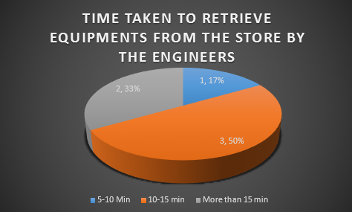

Figure 1 Pie chart

Figure 2 shows opinion on the effectiveness of the current system according to questionnaires from Engineers

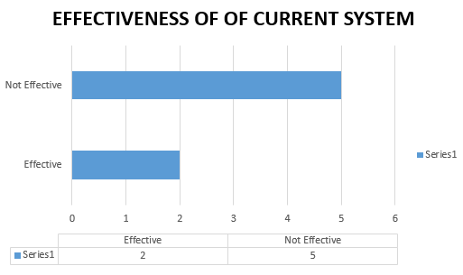

Figure 2 bar graph

Figure 3 shows misplacement of client’s equipment’s by store managers

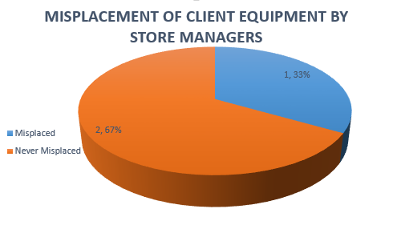

Figure 3 misplacement pie chart

3.5.3 Conclusion

According to the analysis shown above, implementation of the proposed system will be of great value to the company and will improve greatly the way of recording equipment’s. The system will also be of great income through analysis of the various equipment’s and tracking the stage at which the equipment is at.

# 3.5.4 Report of observation

Using this tool, i conducted a survey where i concentrated on areas such as the process which is followed by the Equipment’ from when they are brought in until the day they are collected by the client. First, the store manager had to record the details of the item on a certain book such as the name of the item, serial number, fault of the item, client name and contacts and other components that were accompanying the Equipment. After this the item is loaded into the store and awaits to be checked by the suitable Engineer. Before the Engineer can pick the item he was supposed to record its details again on a different and later do the same on return of the item. An Equipment could be picked for a number of times until the initial problem had been resolved.

The process of recording the details of this item took a huge amount of time and also if not well placed in the store it could take quite some time before locating it in the store. At particular times, the Engineers needed to use known working equipment’s to troubleshoot others and this would really be difficult for them in terms of having to record the item again.

After the item was ready a quotation was prepared at the finance department and sent to the client. Later, the client would come and collect his/her Equipment.

# 3.5.5 Conclusion

After long observation of the processes and work done by the various individuals i realized that the store manager was having a hard time locating the progress of the various items and also making sure that the Engineers who were picking the items form the store had to record the details of the item they picked/returned which was a repetition since all this details were captured when these particular items were brought in for the first time.

The Engineers also wasted a lot of time when locating the items from the store and also when recording the details on the book each and every time they carried out this activities.

The following graph shows the amount of time taken by the various Engineers in putting down the details of an equipment while picking and returning it to the store.

From Figure 4 a lot of time is wasted but with the implementation of the proposed system the time spent will be cut down largely.

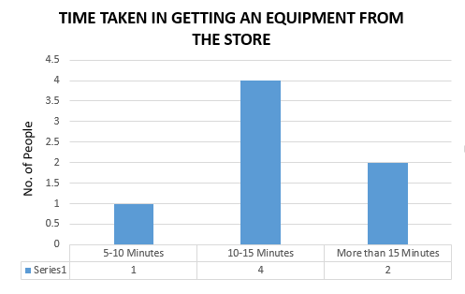

Figure 4 Time bar graph

# 3.10.1 Functional Requirements

Under this phase final requirement specification of the new system where identified functional requirements according to end user specifications.

Creating Account: The system will allow the creation of accounts for the various users of the system.

Manage Account: The administrator should be able to view the activities/items that the various Engineers are working on through their accounts.

Viewing Statistics: The flow of equipment’s in the various categories should be depicted in a proper format that will indicated and capture their movement.

Sending E-mail notifications: The system should be able to capture when the equipment’s are taken and returned to and from the store by the engineer’s.

Configuring sending/receiving E-mails: The administrator for purpose of future reference, should be able to configure the E-mail accounts which will send and record the notifications.

Send Text Messages: Customers should be notified by use of sms about their equipment’s progress and whenever they are ready to be picked.

Archiving equipment’s- After a client has collected his item the store manager should be in a position to archive the equipment for future reference.

Adding Equipment’s: The store manager should be in apposition to add the various equipment’s brought in by the customers into the system to facilitate proper assigning of equipment’s to the Engineers.

Picking/Returning Equipment’s: Engineers through the system, should be able to specify the item they want to pick from the digital store and also returning the same.

Generating reports: In case an Engineer requires to present the work done over a particular period, he/she should be able to generate a report through the system.

Updating Equipment’s: After the Engineer has done some troubleshooting on the equipment and found out what the problem was, he/she should update that information when returning the equipment into the store.

Search Equipment: In case the number of equipment’s has increased over a period of time, one should be able to search for it from the database and view the category in which the equipment is at.

Viewing History/Archive: The Engineers should be able to track the items they have worked on the past.

# 3.10.2 Non-functional Requirements

The non -functional requirements are as follows:

Adaptability – The system will be easy to adapt from one type of environment to another without any difficulties.

Portability – The system will easy to transfer from one work place to another without any negative effect.

Maintainability- The experts should have the ease of maintaining the system by, correcting errors, preventing breakdown, perfecting the system and ensuring that it adapts to the changing technology and needs of the user.

Usability – The system will be friendly to all users with or without much computer knowledge due to simple user interfaces and proper documentation of the system.

Scalability – There will be a room for addition of more functionalities into the system due to growth of technology and increased user requirements.

Economy – The system will be affordable and within the budget specified.

# 3.8 Physical and logical design

# 3.8.1 Process Flowchart

Figure 5 shows the process followed when an equipment is brought in for repair

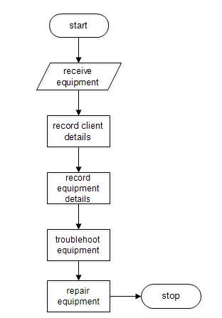

Figure 5 process flow

# 3.8.2 Use case Diagram

Figure 6 show the various uses that can be carried out by the various actors in the system

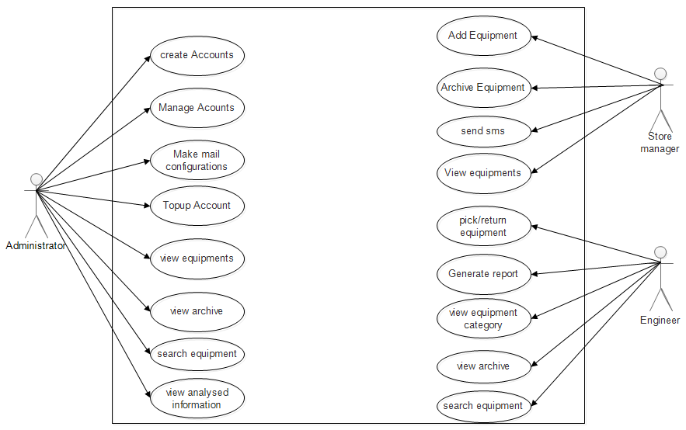

Figure 6 use case diagram

# 3.8.3 Login flowchart

Figure 7 shows the process of user login

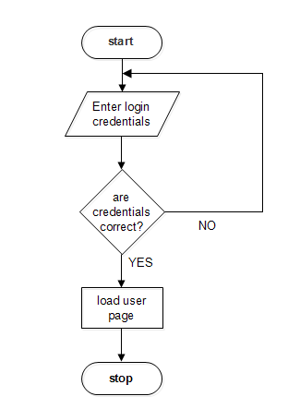

Figure 7 login process

# 3.8.4 Administrators’ Activity diagram

Figure 8 shows the activities that are carried out by the administrator in the system

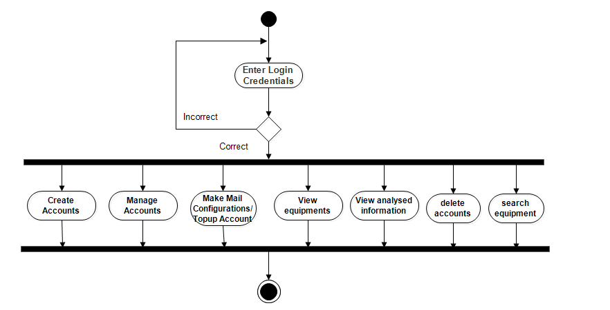

Figure 8 Admin activity diagram

# 3.8.5 Store Managers’ Activity diagram

Figure 9 shows the activities that are undertaken by the store manager in the system.

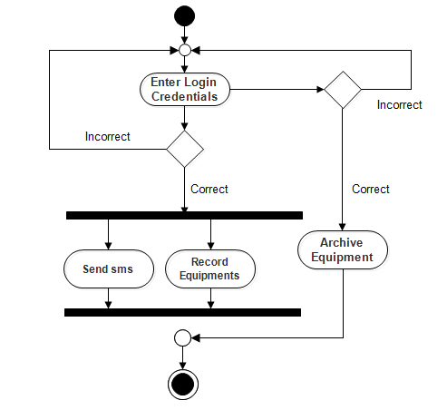

Figure 9 store manager activity diagram

# 3.8.6 Engineers’ Activity diagram

Figure 10 shows the activities that are carried out by the Engineers in the system

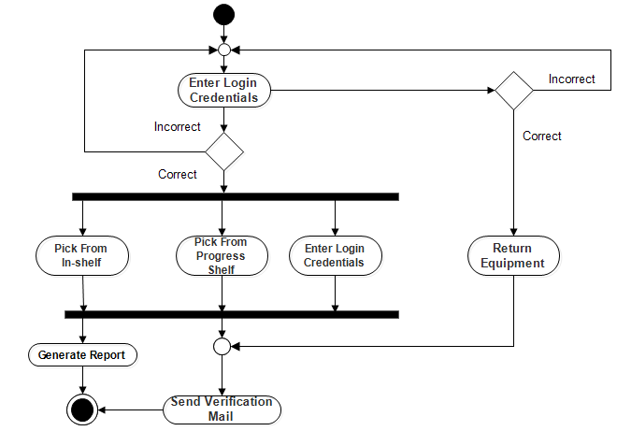

Figure 10 Engineer activity diagram

# 3.8.7 Engineers flowchart

Figure 11 shows the process followed and the activities involved in picking and returning of equipment’s.

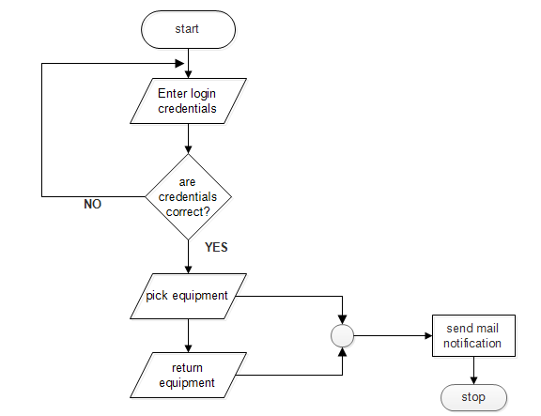

Figure 11 picking and returning of equipment’s

# 3.8.8 Administrators’ Sequence diagram

Figure 12 shows the sequence in which the administrator carries out his tasks

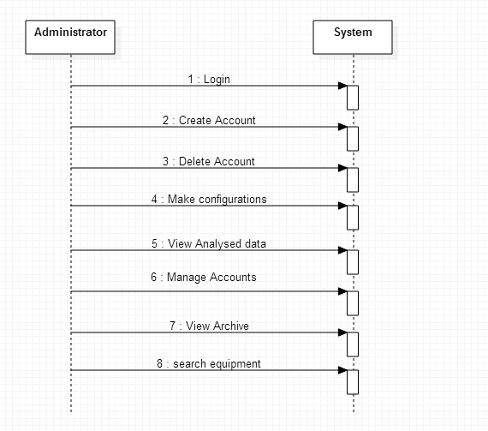

Figure 12 Admin sequence diagram

# 3.8.9 Engineers’ Sequence Diagram

Figure 13 shows sequence of activities that occur between the Engineer and the system.

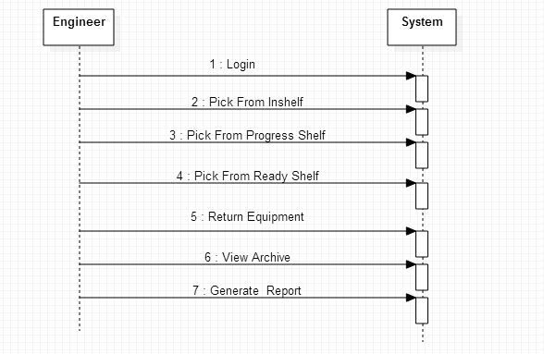

Figure 13 Engineer sequence diagram

# 3.8.10 Class Diagram

Figure 13 shows the various classes, variables and functions that they contain

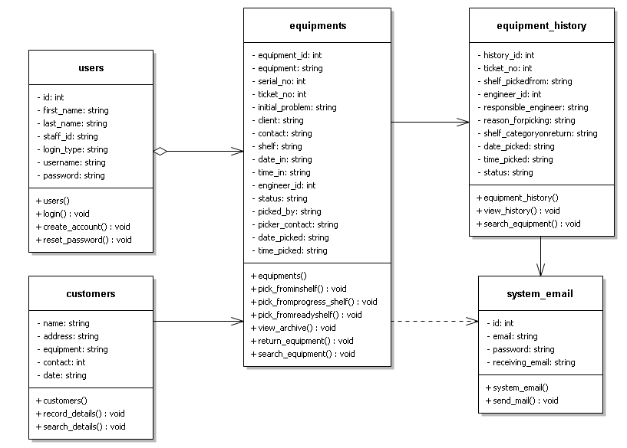

Figure 14 Class diagram

# 3.8.11 Interface Design

# 3.8.12 Login Interface/home Page

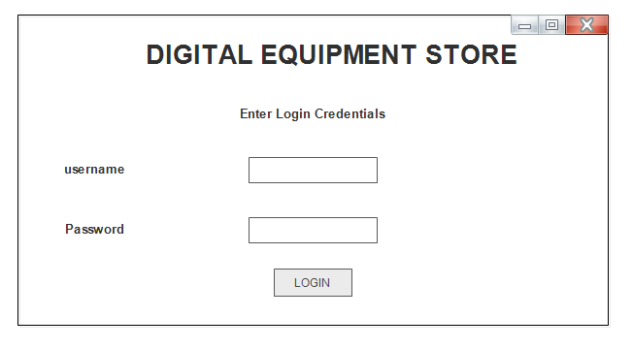

Figure 15 home page/login mockup

# 3.8.13 Admin Interface

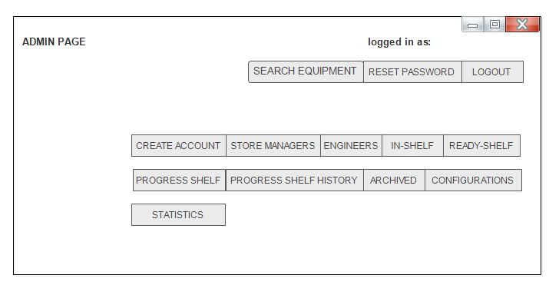

Figure 16 Admin interface

# 3.8.14 Store Managers’ Interface

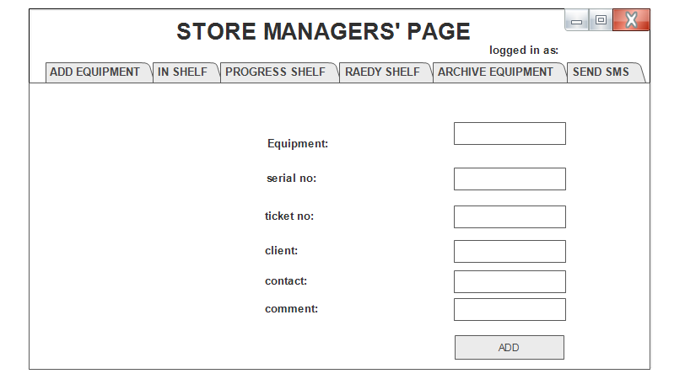

Figure 17 store manager mockup

# 3.9 System Architecture

# 3.9.1 Deployment Diagram

This is the conceptual model that defines the logical view of the system. The diagram below shows the various components which will be required during the deployment of the system. The database/application server will hold the database of the system and also the application will be hosted on the same machine or rather they can still be separated and each will sit on a different hardware depending on the resources available. After successful deployment of the system on main branch they will require a proxy server to handle the security issues and facilitate smooth access of the application within the organizations network.

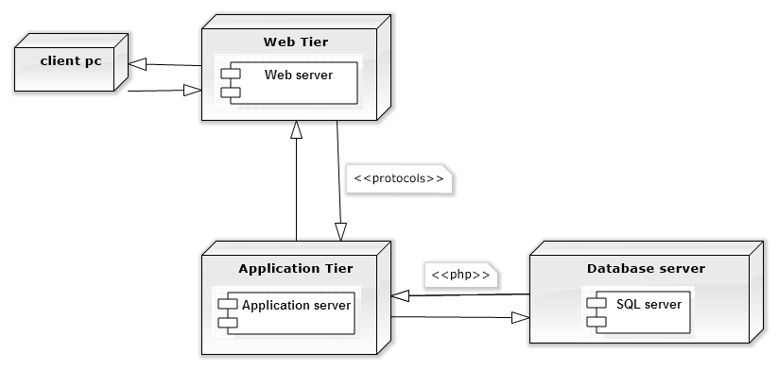

Figure 18 Deployment diagram

# 3.9.2 System Framework

The system framework employed is the MVC model. It's a widely adopted pattern across many languages and implementation framework whose purpose is to achieve a clean separation between three components of most web application. They include:

1. Model- It's there to respond to queries from the user and encapsulate application states. It basically handles the database part.
2. View-Provide an interface for which the user can interact with the model through the controller.
3. Controller-Defines the application behavior and maps user actions to the model part.

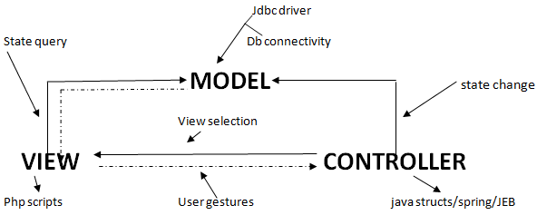



# 3.10 Database

# 3.10.1 Database design

**Table: users**

|  |  |  |  |  |  |
| --- | --- | --- | --- | --- | --- |
| **Field Name** | **Data Type** | **Size** | **Description** | **Field Table** | **Required** |
| id | INT | 4 |  | id | Yes |
| First_name | Text | 15 |  | First_name | Yes |
| Last_name | Text | 15 |  | Last_name | Yes |
| Staff_id | Text | 7 | Primary Key | Staff_id | Yes |
| Login_type | Text | 15 |  | Login_type | Yes |
| Username | Text | 15 |  | Username | Yes |
| Password | Text | 20 |  | Password | Yes |

Table 2 users table

**Table: customers**

|  |  |  |  |  |  |
| --- | --- | --- | --- | --- | --- |
| Field name | Data type | Size | Description | Field Table | Required |
| name | Text | 20 |  | name | YES |
| address | Text | 15 |  | address | YES |
| equipment | Text | 20 |  | equipment | YES |
| contact | Text | 15 |  | contact | YES |

Table 3 Customers table

**Table: Equipment store**

|  |  |  |  |  |  |
| --- | --- | --- | --- | --- | --- |
| **Field name** | **Data type** | **Size** | **Description** | **Field Table** | **Required** |
| Equipment_id | Int | 3 |  | Equipment_id | Yes |
| Equipment | Text | 15 |  | Equipment | Yes |
| Serial no | Text | 20 |  | Serial no | Yes |
| Ticket no | Int | 4 | Primary Key | Ticket no | Yes |
| Initial problem | Text | 50 |  | Initial problem | Yes |
| Client | Text | 20 |  | Client | Yes |
| Contact | Text | 15 |  | Contact | Yes |
| Shelf | Text | 10 |  | Shelf | Yes |
| Date_in | Date | 10 |  | Date_in | Yes |
| Time_in | Date/Time | 10 |  | Time_in | Yes |
| Engineer_id | Text | 15 |  | Engineer_id | Yes |
| Status | Text | 10 |  | Status | Yes |
| Picked_by | Text | 10 |  | Picked_by | Yes |
| Picker_contact | Text | 15 |  | Picker_contact | Yes |
| Date_picked | Date | 12 |  | Date_picked | Yes |
| Time_picked | Date/Time | 10 |  | Time_picked | Yes |

Table 4 Equipments table

**Table: System Email**

|  |  |  |  |  |  |
| --- | --- | --- | --- | --- | --- |
| **Field name** | **Data Type** | **Size** | **Description** | **Field Table** | **Required** |
| Id | Int | 2 |  | id | Yes |
| Sending Email | Text | 30 |  | Sending Email | Yes |
| Password | Text | 20 |  | Password | Yes |
| Receiving Email | Text | 30 |  | Receiving Email | Yes |

Table 5 System mail

**Table: Picked Equipment History**

|  |  |  |  |  |  |
| --- | --- | --- | --- | --- | --- |
| **Field Name** | **Data Type** | **Size** | **Description** | **Field Table** | **Required** |
| History_id | Int | 6 | Primary Key | History_id | Yes |
| Ticket_no | Int | 4 |  | Ticket_no | Yes |
| Shelf_pickedfrom | Text | 3 |  | Shelf_pickedfrom | Yes |
| Engineer_id | Int | 7 |  | Engineer_id | Yes |
| Responsible_engineer | Text | 10 |  | Responsible_id | Yes |
| Reason_forpicking | Text | 20 |  | Reason_forpicking | Yes |
| Shelf_category_onreturn | Text | 15 |  | Shelf_category_onreturn | Yes |
| Date_picked | Date | 12 |  | Date_picked | Yes |
| Time_picked | Date/Time | 10 |  | Time_picked | Yes |
| Status | Text | 16 |  | Status | Yes |

Table 6 Equipment history

# 3.11 Database Normalization

This was carried out in order to reduce redundancy of information.

Un-normalized Tables of Data

id,first_name,last_name,staff_id,login_type,username,password,equipment_id,equipment,serial_no,ticket_no,initial_problem,client,contact,shelf,date_in,time_in,engineer_id,status,picked_by,picker_contact,date_picked,time_picked,history_id,ticket_no,shelf_pickedfrom,engineer_id,responsible_engineer,reason_forpicking,shelf_category_onreturn,date_picked,time_picked,status,id,email,password,receiving_email, name, address, equipment, contact, date

**1st Normalization**

Each field in a table should contain different record and the primary key should be identified.

Table 1 (id, first_name, last_name, staff_id, login_type, username, password)

Table 2 (equipment_id, equipment, serial_no, ticket_no, initial_problem, client, contact, shelf

,date_in, time_in)

Table 3 (history_id, ticket_no, shelf_pickedfrom, engineer_id, responsible_engineer,

reason_forpicking, shelf_category_onreturn,date_picked, time_picked, status)

Table 4 (id, email, password, receiving_email, sending_email)

Table 5 (name, address, equipment, contact, date)

**2nd Normalization**

Each field in a table that does not relate to another field must be an occupation of the other fields in the table.

1. Users Table

id, first_name, last_name, staff_id, login_type, username, password

1. Equipment Table

equipment_id, equipment, serial_no, ticket_no, initial_problem, client, contact, shelf

,date_in, time_in

1. Equipment history Table

history_id, ticket_no, shelf_pickedfrom, engineer_id, responsible_engineer,

reason_forpicking, shelf_category_onreturn, date_picked, time_picked, status

1. System email Table

id, email, password, receiving_email, sending_email

1. Customers Table

name, address, equipment, contact, date

**Tables after Normalization**

1. users table
2. Equipment Store Table
3. Picked equipment history Table
4. System email Table
5. Customer Table

# 3.12 Entity Relationship Diagram

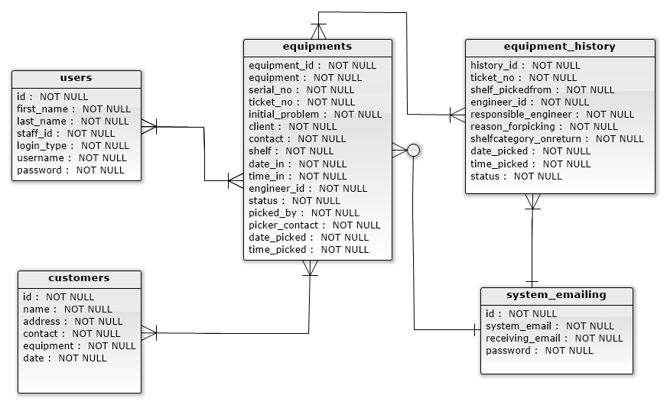

Figure 19 Entity relationship diagram

# 

# CHAPTER FOUR

**SYSTEM CODE GENERATION AND TESTING,**

**CONCLUSIONS AND RECOMMENDATIONS**

# 4.1 Introduction

This chapter contains the sample code of the system in terms of functions and also the various test plans that were carried out to make sure that the system was undertaking the various activities in the correct manner. The chapter also contains the challenges that were faced during system development and the recommendations suggested.

# 4.2 System code generation

Below are sample codes that are contained in the system that represent then various functionalities of the system.

**Database connectivity**

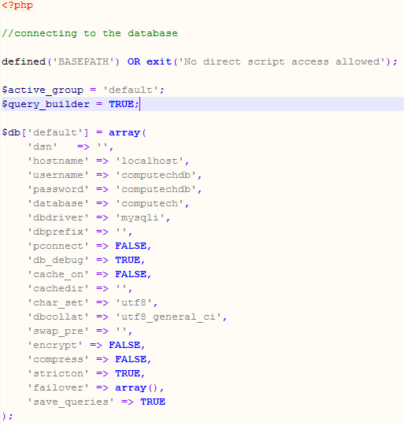

**Login Function**

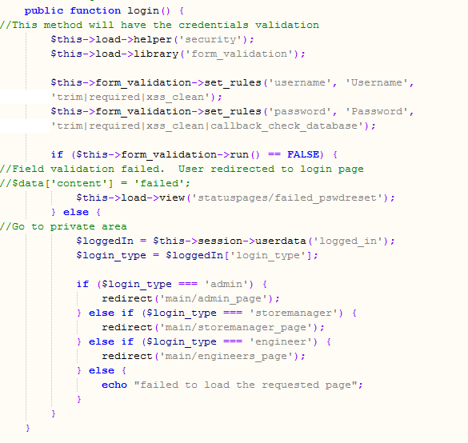

**Validating password**

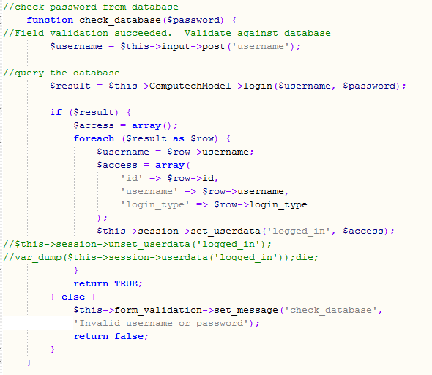

**Logout**

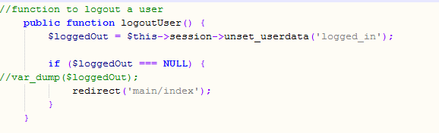

# 4.3 Testing

Testing was done to determine whether the system was meeting the user requirements, it was done after the system was put in place

# 4.3.1 Test plan

The Software Test Plan is designed to prescribe the scope, approach, resources, and schedule of all testing activities. The plan will identify items to be tested, the features to be tested, the types of testing to be performed, the personnel responsible for testing, the resources and schedule required to complete testing. The purpose of the software test plan is such as:

To achieve the correct code and ensure all Functional and Design

Requirements are implemented as specified in the documentation.

To provide a procedure for Unit and System Testing.

To identify the test methods for Unit and System Testing.

The following is test plan which was used:

1. GUI testing
2. Unit testing
3. Integration testing
4. System testing
5. Module testing
6. Acceptance testing

# 4.3.2 Test Results

GUI testing

This was done to ensure that first the navigation within the system was easy and that the color used in the entire system and ensuring that the sequencing of events was proper and happened as specified.

|  |  |  |  |
| --- | --- | --- | --- |
| Type of test | Test case | Given results | Expected results |
| GUI testing | User interface navigation | The system was able to navigate from one page to the other with the use of buttons | The system should give the user an easy time to navigate from one place to the other. |
| color | Brightness and color was not the best since it varied from one browser to the other | The system should be able adjust and fit from one environment to the other. |
| sequencing | All events occurred in the order in which they were expected to. | All set events should be able to initiate properly and at the right time and also give proper values |

Table 7 GUI testing

Unit Testing

Unit testing on the digital equipment store management information system concentrated on verification on the smallest element of the software module.

|  |  |  |  |
| --- | --- | --- | --- |
| Type of Test | Features to be tested | Given results | Expected results results |
| Unit Test | Ability to grant access to the users | The system was able to grant access to the relevant parties | The system should be able to allow only those users that exist in the system to login into it |
| Friendliness of user interface in navigation | The various buttons located in the interface were able to respond to the expected result when clicked | At click of buttons in the UI, the system should be able to respond and initiate the expected results |
| White Box Testing | Internal Structure and design | The system should be able to respond to various queries from the general users | The system should be able respond to various queries from the user |

Table 8 Unit test

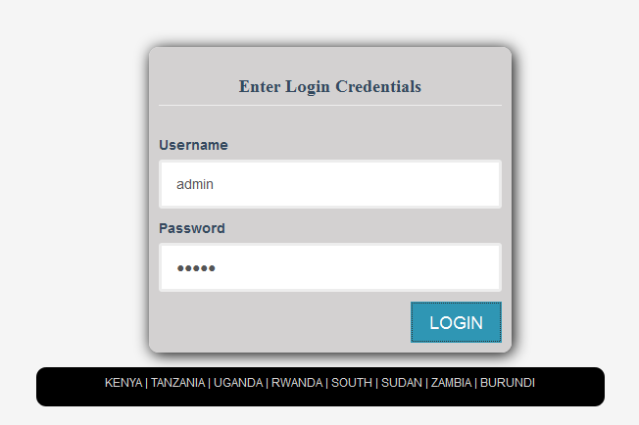

Acceptance Testing

This was carried out to test the user acceptance of the system after completion of the system development and testing. It involved introducing the new system to the user and giving them the system performance.

|  |  |  |  |
| --- | --- | --- | --- |
| Types of Test | Areas To be Tested | Given Results | Expected Results |
| User requirements | Finding out whether the system met the specified requirements specified by the user | The system was able to meet most of the given user requirements while others were much complex to achieve due to time factor and others will be recommended to be included in the future | The system should be able to meet a larger part of the requirements specified by the client while still creating room for additional requirements. |
| Black Box testing | Working of the internal structure and design | All internal components were able to communicate effectively | Efficient internal working structure |

Table 9 Acceptance testing

Module Testing

The module interface was tested to ensure that information properly flows into and out of the software unit tested. The local data structure was considered to ensure that data stored temporarily maintained its integrity for all stages in an algorithm’s execution.

|  |  |  |  |
| --- | --- | --- | --- |
| Type of Test | Area To be Tested | Given Result | Expected Results |
| Module Testing | Add equipment module | The system was able to add newly brought in equipment’s into the system | The system should be able to add the equipment’s into the system and categorize them according to their states |
| sms module | Store manager was able to send test sms’s with the use of the system | The system should be able to send text messages to the customers. |
| Emailing module | The module was able to capture the details of the equipment’s taken from the store and send notifications | The system should be able to send notification mails concerning the movement of equipment’s |

Table 10 Module testing

Integration Testing

This is the testing was done to find out whether the various modules making up the system were able to work together and generate the expected results. This was also done to determine whether the client and the server interacted correctly over the network.

|  |  |  |  |
| --- | --- | --- | --- |
| Type of Testing | Area To be Tested | Given Results | Expected Results |
| Integration testing | The login, mailing and the Equipment additional forms | The system was able to manipulate the various values and items in the database | The system shall be able to insert, delete, retrieve, update and view various details in the database |

Table 11 Integration testing

Functional Testing

It’s done to validate an application and ensure that the system performs all the expected functionalities correctly. It included testing of each function step by step including the database modules.

|  |  |  |  |
| --- | --- | --- | --- |
| Type of test | Areas to be tested | Given results | Expected results |
| Functional testing | Entire system | All the deployed functions were able to perform and also interact with the modules contained in the system | All functions should perform and result to the expected outputs and the interaction between the various components. |

Table 12 Functional testing

00000000000000000000000000000000000000000000000000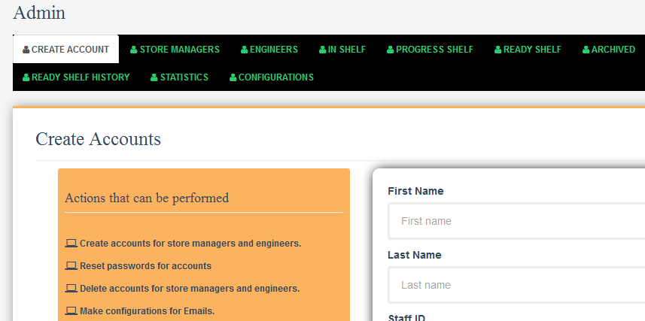

# 4.4 Conclusion

Comparing the manual and the computerized system, the computerized system was more preferable because it enhanced standards and work environment as well as efficiency and reliability. The system also improved the working of the Engineers by helping them keep track of the equipment’s they are working on. I believe the system has met the predefined requirements thus able to perform its function well effectively and efficiently.

# 4.5 Limitations

During the process one of the problems i encountered was data collection since the Engineers and the store managers were very busy and they were not willing to give the information because of confidentiality concerned with companies terms and conditions and also i didn’t have good skills in programming but due to hard work and support from my friends and supervisor i was able to proceed just fine and did the best i could.

# 4.6 Recommendations

I recommend the implementation of the computerized system in the service Centre to help solve a large number of problems experienced. Improvements can be made on this system to accommodate more features that will improve the performance of the system such as the payment module and client module so that they can be able to follow on the progress of their items. The system should also be implemented in other institutions facing similar challenges.

# References

1. Breiner, Kai, Marc Seissler, Gerrit Meixner, Peter Forbrig, Ahmed Seffah, and Kerstin Klockner, 2010, "*PEICS Towards HCI Patterns into Engineering of Interactive Systems*." *PEICS '10.* Berlin: ACM.
2. Borchers, Jan O., 2012, "*A Pattern Approach to Interaction Design*." *AI & Society*.
3. Gamma, Erich, Richard Helm, Ralph Johnson, and John Vlissides., 2005, *Design Patterns.* Second Printing. Reading, MA: Addison-Wesley Publishing Company.
4. Leacock, Matt, Erin Malone, and Chanel Wheeler, 2007, "Implementing a Pattern Library in the Real World: A Yahoo! Case Study." *ASIS&T IA Summit.* Montreal.
5. Nilsson, Erik G., 2009, "Design Patterns for User Interface for Mobile Applications." *Advances in Engineering Software.*
6. Seffah, Ahmed., 2012 "The Evolution of Design Patterns in HCI: Pattern Languages to Pattern-Oriented Design." *PEICS '10.* Berlin: ACM.
7. S.A Conger, R.O Mason, 2010, *Planning and designing Effective Web sites*, Course Technology.
8. Tidwell, Jenifer., 2010, *Designing Interfaces.* 2nd Edition. Sebastopol, CA: O'Reilly Media, Inc.
9. Don Artest, 2012, *Software Requirements Specification(SRS) version 2.0,* Pressman Publishers, CA
10. Kangethe M. Samuel, 2012, *Introduction to systems analysis and design,* JKF Publishers, Nairobi
11. Aries L Mansour, 2013, *Project Proposal Writing and Presentation,* [www.wikipedia.org/wiki/proposalwriting](http://www.wikipedia.org/wiki/proposalwriting)

# Appendices

# 1.11.0 Resources, Timeplan and Budge

# 1.11.1 Hardware Requirements

1. Computer: Gen 3 Core i3 of 3.0GHZ 4GB of RAM 500 GB hard disk or higher specifications, to run the application.
2. A printer: To print out the reports generated by the various users.
3. 2GB Flash Disk: To occasionally port data/transfer to another computer if need arises.

# 1.11.2 Software Requirements

1. Windows 8 Operating system: To provide a platform for accessing the system.
2. AdobeReader: For easier printing of reports.
3. Notepad ++: To provide a platform for writing the code.
4. Wamp server: Contains features such as MySQL for creation of the database.

# 1.11.3 Human Resources

1. System administrator
2. End users

**Others**

1. Internet connection- For sending verification messages.

# Appendix i. Budget

Table 13 shows the various items that will be required during system development and testing and their adjacent prices

Table 13 Budget

|  |  |  |  |  |
| --- | --- | --- | --- | --- |
| ITEM NO | ITEM NAME | UNIT | UNIT COST | AMOUNT(Ksh) |
| 1 | Computer System | 1 | 40,000 | 40,000.00 |
| 2 | Printer | 1 | 1,500 | 1,500.00 |
| 3 | Traveling | - | 1,200 | 1,200.00 |
| 4 | Stationeries | - | 180 | 900.00 |
| 5 | Flash Disk 2 GB | 1 | 600 | 600.00 |
|  | TOTAL COST |  |  | Sh44,000.00 |

Table 14 Budget

Budget Justification

* The operating system will provide the platform on which the system will run.
* Flash disk will be used for transferring files between the computers if need arises
* The computer system will be used as server to run the application.
* Internet connection will be required by the system in sending of verification messages to the Store manager.
* Printer will be used to print the reports generated by the system administrator and the Engineers.

# Appendix ii. Gantt chart

Figure 20 shows the order of activities carried out and their corresponding durations in terms of hours

Figure 20 Gantt chart

|  |  |  |  |  |  |  |  |  |  |  |  |  |  |  |
| --- | --- | --- | --- | --- | --- | --- | --- | --- | --- | --- | --- | --- | --- | --- |
| Activities | Time in hours | 1 | 2 | 3 | 4 | 5 | 6 | 7 | 8 | 9 | 10 | 11 | 12 | 13 |
| Data collection | 60 |  |  |  |  |  |  |  |  |  |  |  |  |  |
| Requirement Analysis | 84 |  |  |  |  |  |  |  |  |  |  |  |  |  |
| Requirement Specification | 30 |  |  |  |  |  |  |  |  |  |  |  |  |  |
| Database design | 30 |  |  |  |  |  |  |  |  |  |  |  |  |  |
| Interface/UI design | 30 |  |  |  |  |  |  |  |  |  |  |  |  |  |
| Coding | 250 |  |  |  |  |  |  |  |  |  |  |  |  |  |
| Testing | 20 |  |  |  |  |  |  |  |  |  |  |  |  |  |
| Documentation | 80 |  |  |  |  |  |  |  |  |  |  |  |  |  |
| Implementation | 10 |  |  |  |  |  |  |  |  |  |  |  |  |  |

**KEY**

Predicted Duration

# Appendix iii. Work Plan

Table 15 shows the duration taken to carry out the various phases and the expected deliverables

|  |  |  |  |  |  |  |
| --- | --- | --- | --- | --- | --- | --- |
| Task | Duration in hrs | Expected start date | Actual start date | Expected finish date | Actual finish date | Deliverables |
| Data collection | 60 | 10/5/2016 | 10/5/2016 | 13/5/2016 | 14/5/2016 | Data |
| Analysis | 84 | 15/5/2016 | 15/5/2016 | 19/5/2016 | 20/5/2016 | Requirements |
| Proposal writing | 192 | 21/5/2016 | 21/5/2016 | 12/6/2016 | 18/6/2016 | Proposal document |
| Proposal  presentation | 8 | 23/6/2016 | 23/62016 | 23/6/2016 | 23/6/2016 | Proposal |
| System Design | 60 | 10/7/2026 | 10/7/2026 | 20/7/2016 | 21/7/2016 | System Design |
| System coding | 250 | 1/8/2016 | 2/8/2016 | 20/10/2016 | 5/11/2016 | Working model |
| System  Implementation | 60 | 15/11/2016 | 15/11/2016 | 16/11/2016 | 16/9/2016 | Implementation |
| System Testing & Maintenance | 20 | 17/11/2016 | 17/11/2016 | 18/9/2016 | 18/11/2016 | Working model |
| Project Documentation | 80 | 19/11/2016 | 19/11/2016 | 20/11/2016 | 20/11/2016 | Documentation |
| Project Presentation | 1 | 22/11/2016 | 22/11/2016 | 22/11/2016 | 22/11/2016 | System |

Table 15 Work plan

# Appendix iv: Questionnaires

Dear Respondent,

I'm Murigi D Chege from Jomo Kenyatta University of Agriculture and Technology pursuing a Bachelors’ degree in information technology. Please take a few minutes to express your opinions on the below questions. Your answers are important to the success of this study. Please answer the following questions with ‘yes or no’ where required. This is the questionnaire that deals with Engineers work in the service center and their day to day activities.

SECTION A: Personal Details

1. Please indicate your Gender

Male [ ]

Female [ ]

2. Please indicate your area(s) of specialization in the service center.

* Printer Engineer
* Laptop Engineer
* Desktop Engineer
* Server Engineer
* UPS/Circuit Engineer

Any other__________________

SECTION B**:** ENGINEER DETAILS

1. What are your duties in the company?

…………………………………………………………………………………………

…………………………………………………………………………………………

…………………………………………………………………………………………

1. How long have you been working for the company?

Less than a year [ ]

More than one year [ ]

1. How long does it take you to pick/retrieve an Equipment from the store?

5-10 Min [ ]

10-15 Min [ ]

More than 15 Min [ ]

1. How do you find out newly brought in Equipment’s in the store?

Alert from store manager [ ]

Physically checking from the store [ ]

1. Have you ever misplaced a clients’ Equipment?

YES [ ]

NO [ ]

1. Which method do you use to present the report of work done?

Word of mouth [ ]

Hard written reports [ ]

Typed reports [ ]

1. Do you have a record of all the Equipment’s you have been working on for past periods?

YES [ ]

NO [ ]

1. How do ever been blamed for lose of an Equipment?

YES [ ]

NO [ ]

1. If yes above, how did you defend yourself?

………………………………………………………………………………………………………………………………………………………………………………………………………………………………………………………………………………

1. Do you find the current way of doing things effective?

YES [ ]

NO [ ]

1. If NO above what recommendations would you give?

Introduction of a new System [ ]

Enhancement of the current system [ ]

Dear Respondent,

I'm Murigi D Chege from Jomo Kenyatta University of Agriculture and Technology pursuing a Bachelors’ degree in information technology. Please take a few minutes to express your opinions on the below questions. Your answers are important to the success of this study. Please answer the following questions with ‘yes or no’ where required. This is the questionnaire that deals with Administrators’ work in the service center and their day to day activities.

SECTION A: Personal Details

1. Please indicate your Gender

Male [ ]

Female [ ]

SECTION B**:** ADMINISTRATORS DETAILS

1. What are your roles as an administrator in the service center?

…………………………………………………………………………………………

…………………………………………………………………………………………

…………………………………………………………………………………………

1. How long have you been working for the company?

Less than a year [ ]

More than one year [ ]

1. How do you monitor the activities being carried out by the various individuals in the service center?

Through written reports [ ]

Enquiring from the store managers/Engineers [ ]

Any other_______________

1. How do you monitor the trend of Equipment in the various stages of repair?

Physically checking from the store [ ]

Enquiring from the store manager [ ]

1. Do you find the current way of doing things effective?

YES [ ]

NO [ ]

1. If NO above what recommendations would you give?

Enhancement of the current way of doing things [ ]

Introduction of an improved automated system [ ]

Dear Respondent,

I'm Murigi D Chege from Jomo Kenyatta University of Agriculture and Technology pursuing a Bachelors’ degree in information technology. Please take a few minutes to express your opinions on the below questions. Your answers are important to the success of this study. Please answer the following questions with ‘yes or no’ where required. This is the questionnaire that deals with Store Managers’ work in the service center and their day to day activities.

SECTION A: Personal Details

1. Please indicate your Gender

Male [ ]

Female [ ]

SECTION B**:** STORE MANAGERS’ DETAILS

1. What are your duties in the company?

…………………………………………………………………………………………

…………………………………………………………………………………………

…………………………………………………………………………………………

1. How long have you been working for the company?

Less than a year [ ]

More than one year [ ]

1. How long does it take you to record a newly brought in Equipment?

5-10 Min [ ]

10-15 Min [ ]

More than 15 Min [ ]

1. How long do you take to retrieve a record of a certain Equipment from your source?

5-10 Min [ ]

10-15 Min [ ]

More than Min [ ]

1. Have you ever misplaced a clients’ Equipment?

YES [ ]

NO [ ]

1. If yes above, what contributed to it?

…………………………………………………………………………………………

…………………………………………………………………………………………

1. How many Equipment’s in average do you receive from your client in a daily basis?

Less than 5 [ ] More than 5 [ ]

1. What are some of the challenges you face when carrying out your day to day activities?

…………………………………………………………………………………………

…………………………………………………………………………………………

…………………………………………………………………………………………

1. Do you find the current way of doing things effective?

YES [ ]

NO [ ]

1. If NO above what recommendations would you give?

Enhancement of the current system [ ]

Introduction of a better system [ ]

Dear Respondent,

I'm Murigi D Chege from Jomo Kenyatta University of Agriculture and Technology pursuing a Bachelors’ degree in information technology. Please take a few minutes to express your opinions on the below questions. Your answers are important to the success of this study. Please answer the following questions with ‘yes or no’ where required. This questionnaire captures the feedback of the various clients of Computech Limited.

SECTION A: Personal Details

1. Please indicate your Gender

Male [ ]

Female [ ]

SECTION B**:** CLIENT DETAILS

1. For how long have you been a client of Computech Limited?

Less than a year [ ]

More than a year [ ]

1. Has the company ever misplaced any of your Equipment’s?

YES [ ]

NO [ ]

1. How long does it take before your Equipment is repaired?

Less than a week [ ]

More than a week [ ]

1. Are there any improvements you would like made by the company?

YES [ ]

NO [ ]

1. If yes above, please comment below.

…………………………………………………………………………………………

…………………………………………………………………………………………

…………………………………………………………………………………………

# Appendix v: User Manual

**System Description**

**For**

**[DIGITAL EQUIPMENT STORE]**

**Document**

**Version: [1.0]**

**Date: [22/11/2016]**